Bash Scripting – Conditional Statement- Tasks
Case Script
It’s actually help us to check the conditions in multiple sub cases. Will assign output fo reach case. If that’s match o/p will appear accordingly.
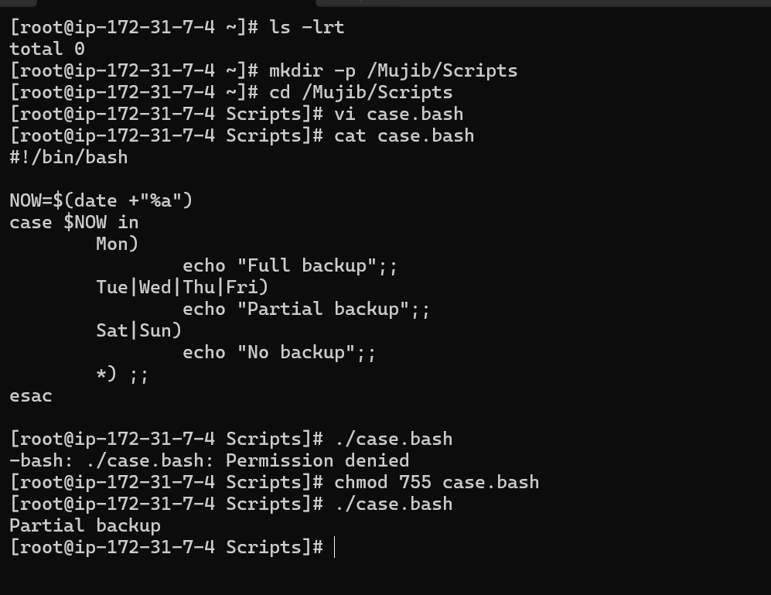
While do condition
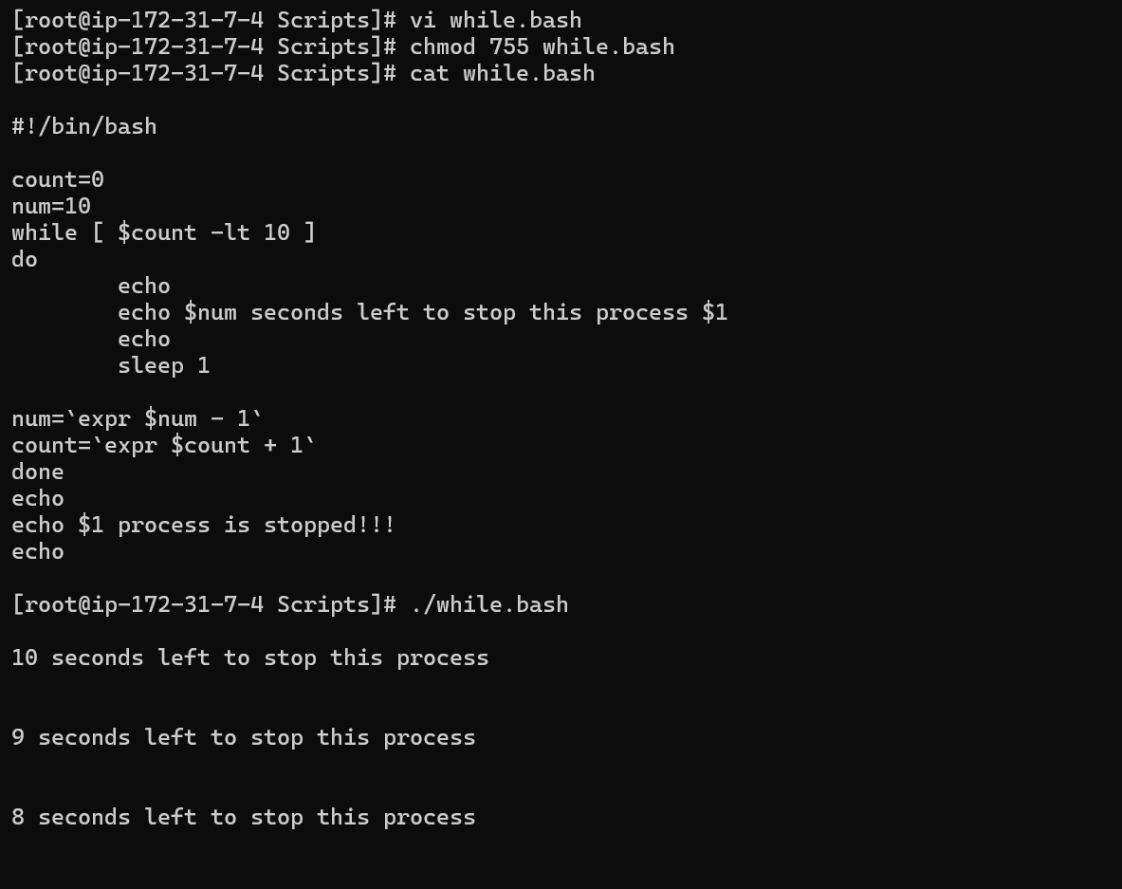
- For loop
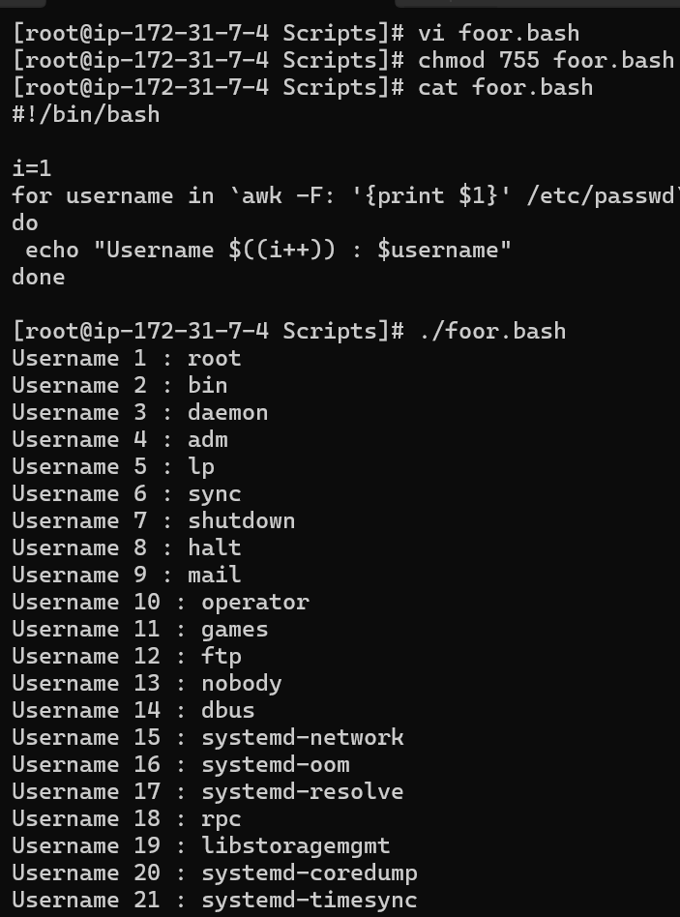
======================================================================

Tasks
1.) Create a bash script to check if a directory is available or not.
Question itself we have the answer – If a directory available or not.
So, I used if condition for this.
File scirpt
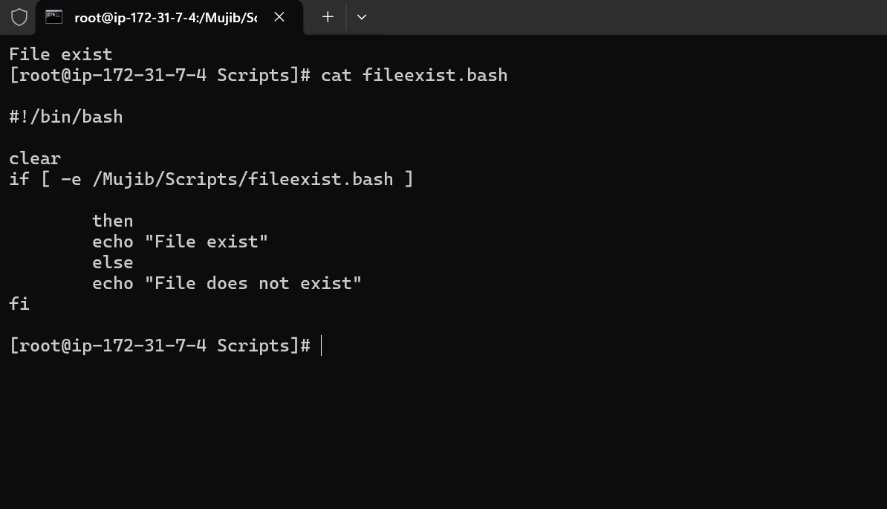
Folder script
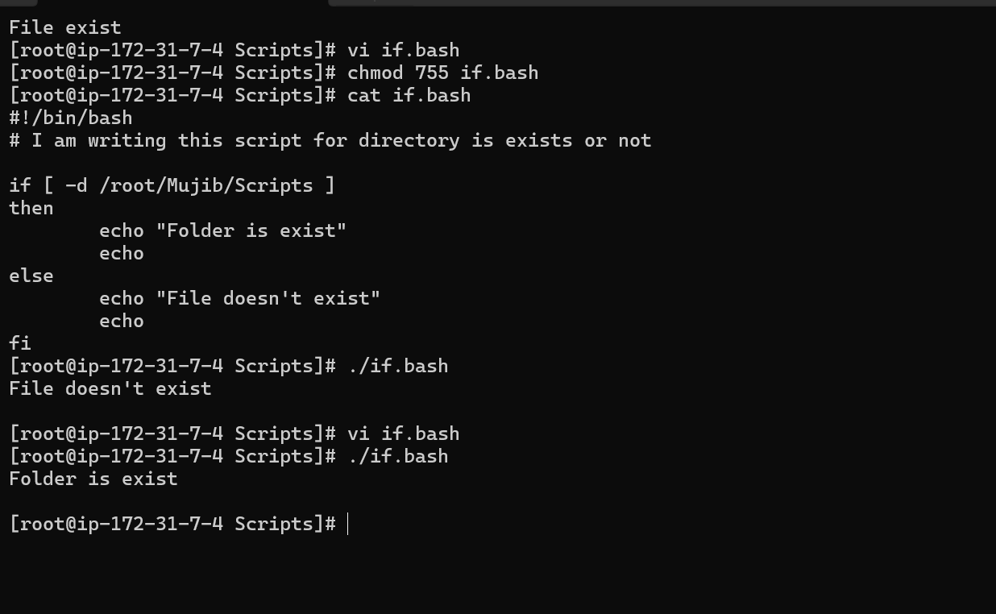
- Create a bash script to create multiple files.
I was created the Multiple files using for loop, Because we are going to create a files using a variables. So, For loop only will help us to do that.
This condition will run until the specifies variable condition becomes true.
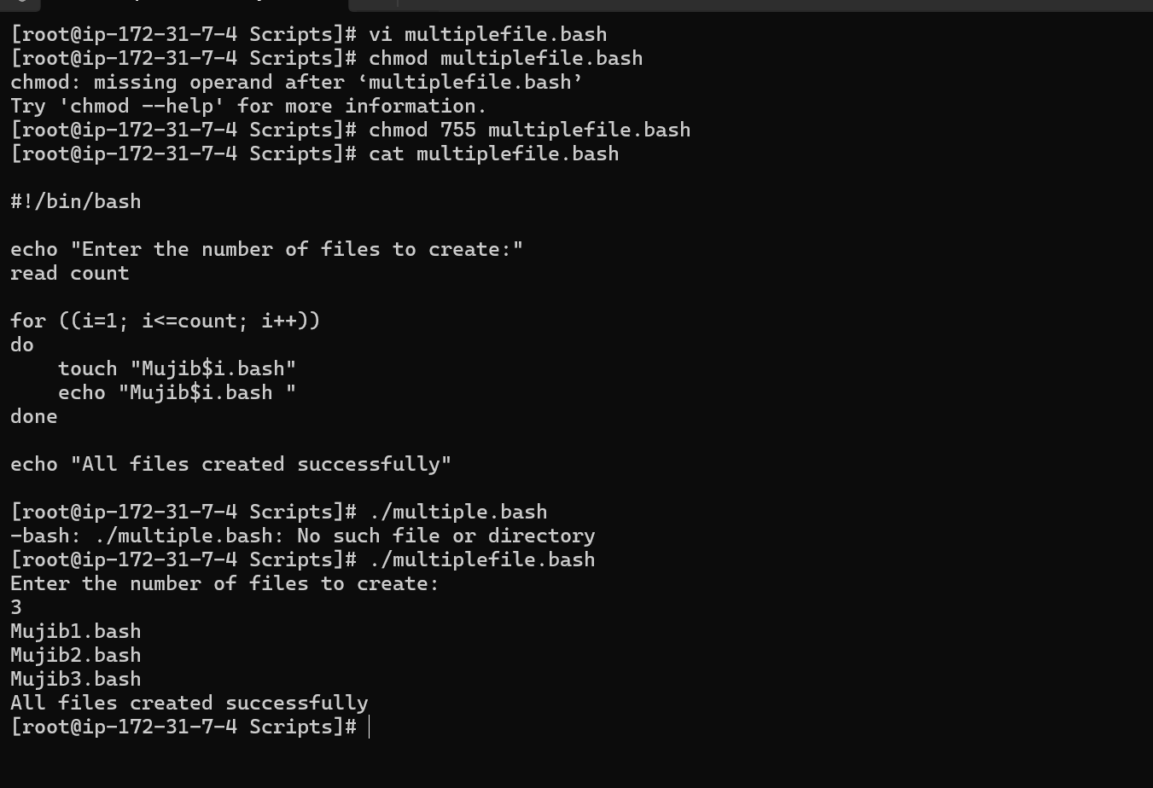
- Create a bash script to take a backup of a directory.
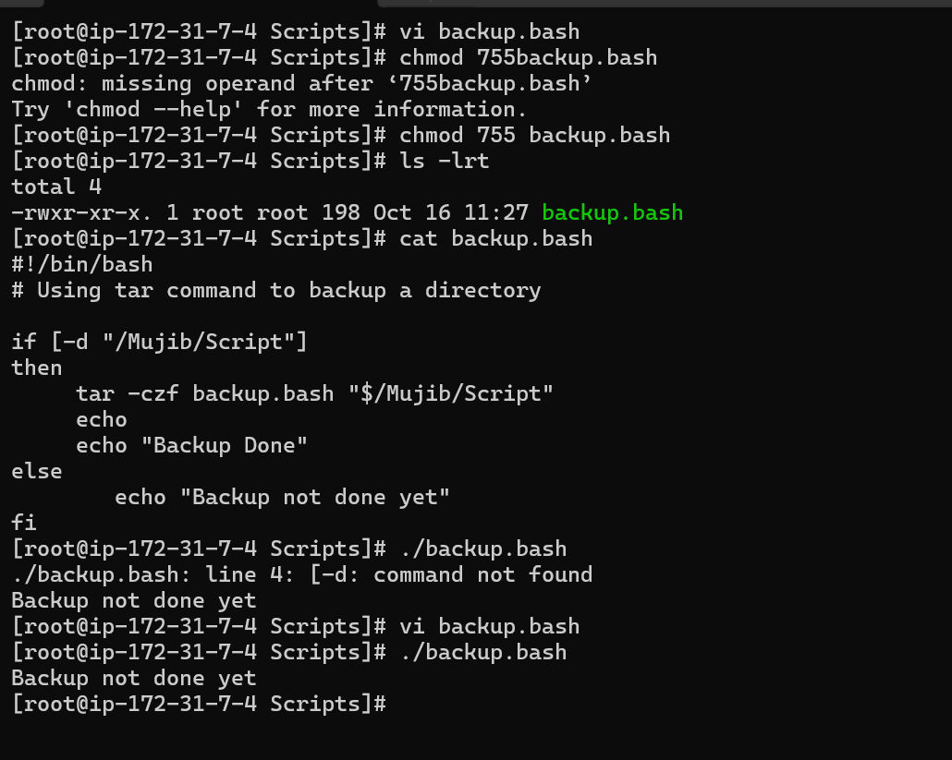
I used if condition with tar command for backup…
- Create a bash script to install Nginx on an EC2 server.
Usual steps only, Just I added all the steps in scripts which we follow step by step during install any service. (nginx, httpd, tomcat)
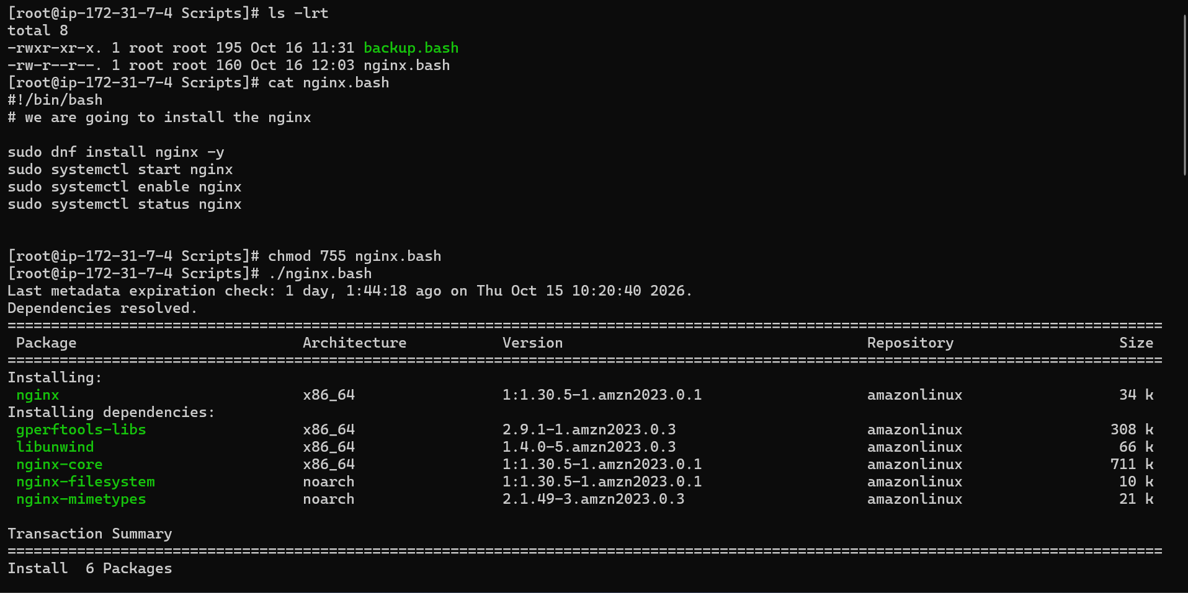
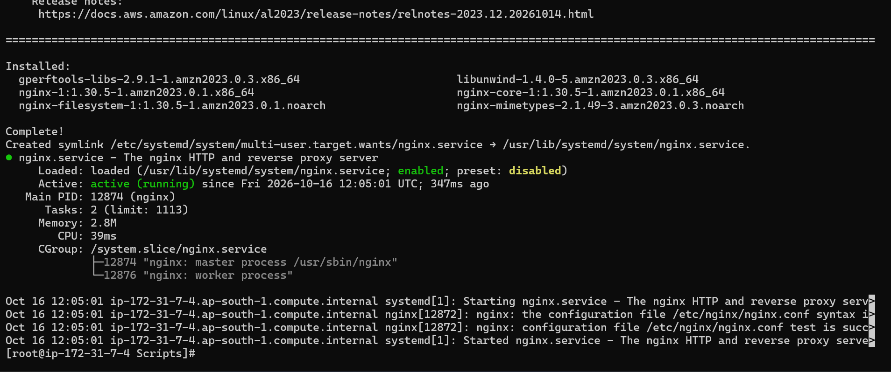
status is running.
I checked with this sudo systemctl is-active nginx command service is active or not.
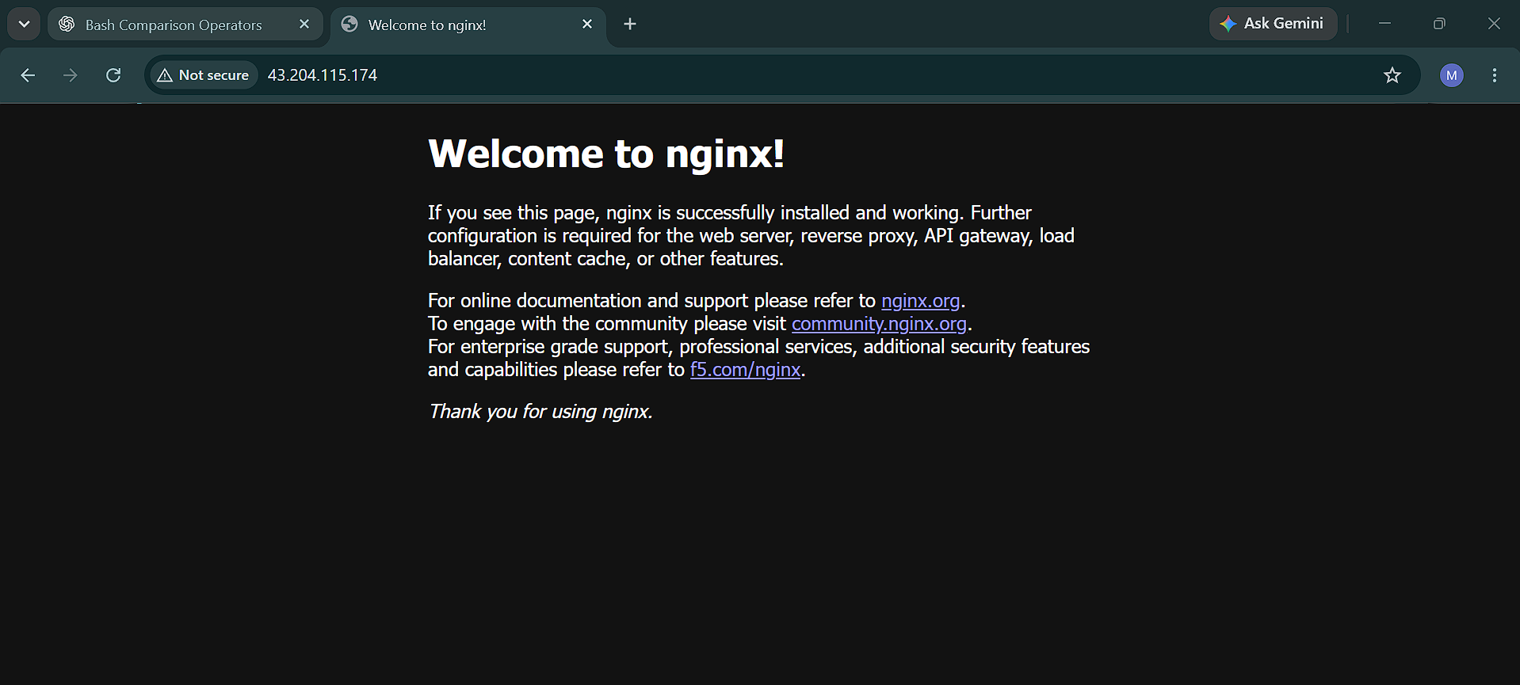

- Create a bash script to install Apache Tomcat on an EC2 server.
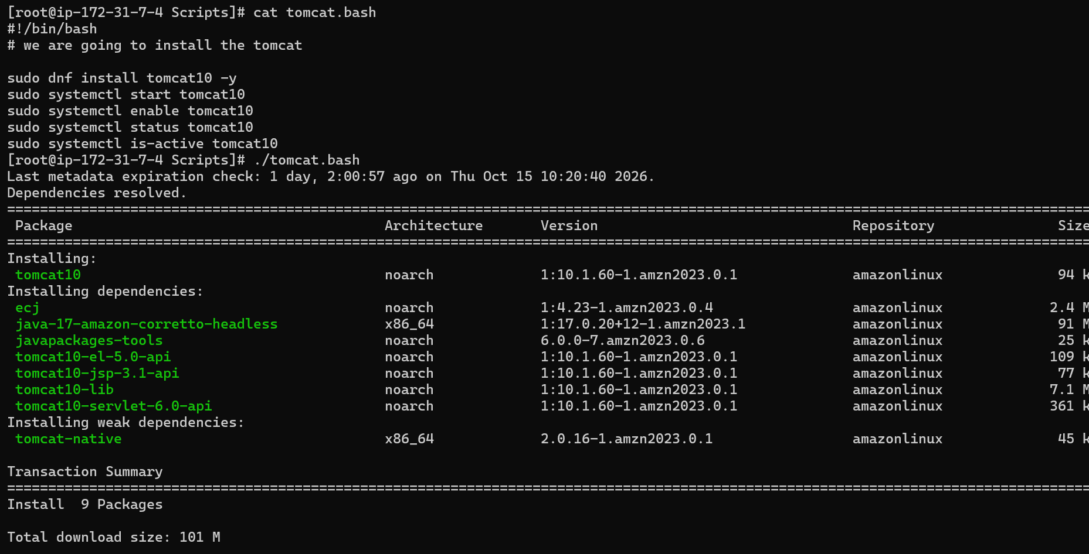
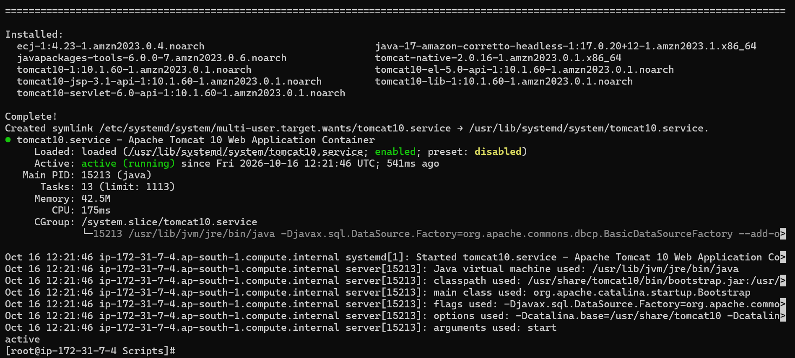
Service is running on 8080 port also, In browser
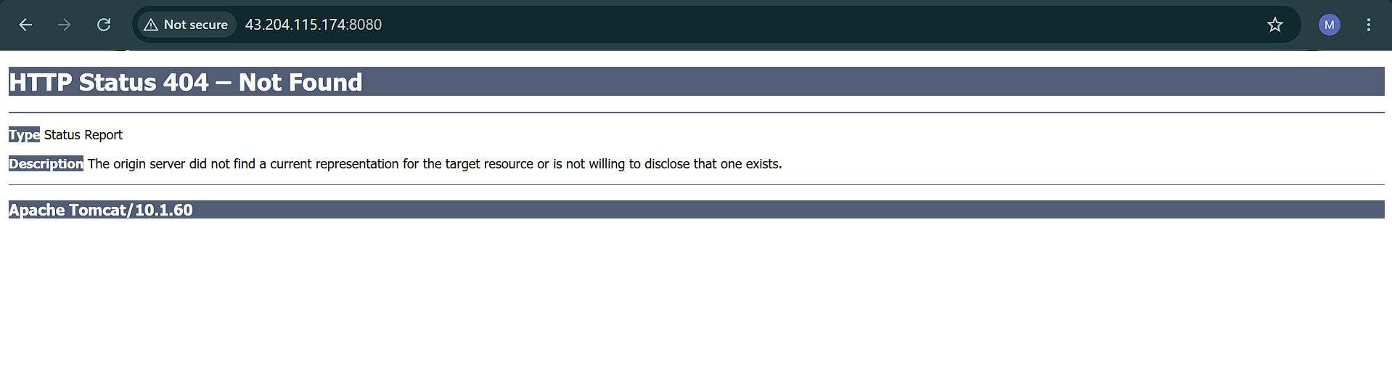

- Create a bash script to check if the Nginx service is running, if not running then script should start the service.
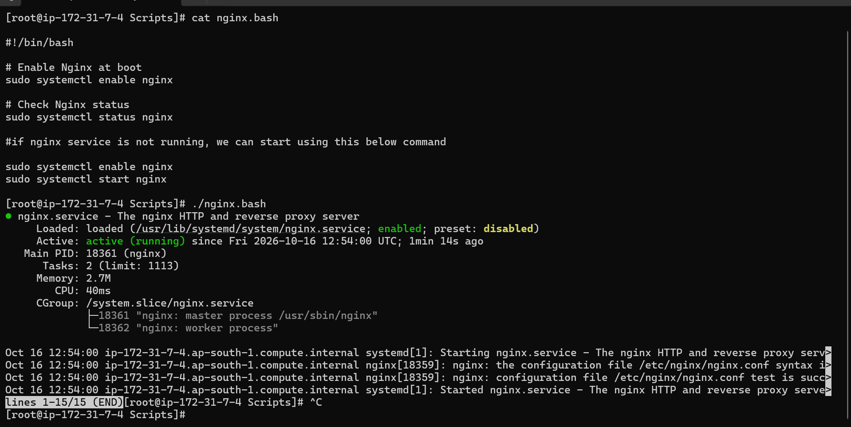
- Create a bash script for a calculator.
while creating bash script for simple calculation, (1/0 is infinity) If suppose user gave second input as 0 that division is not appropriate so, I just added an if condition for that.
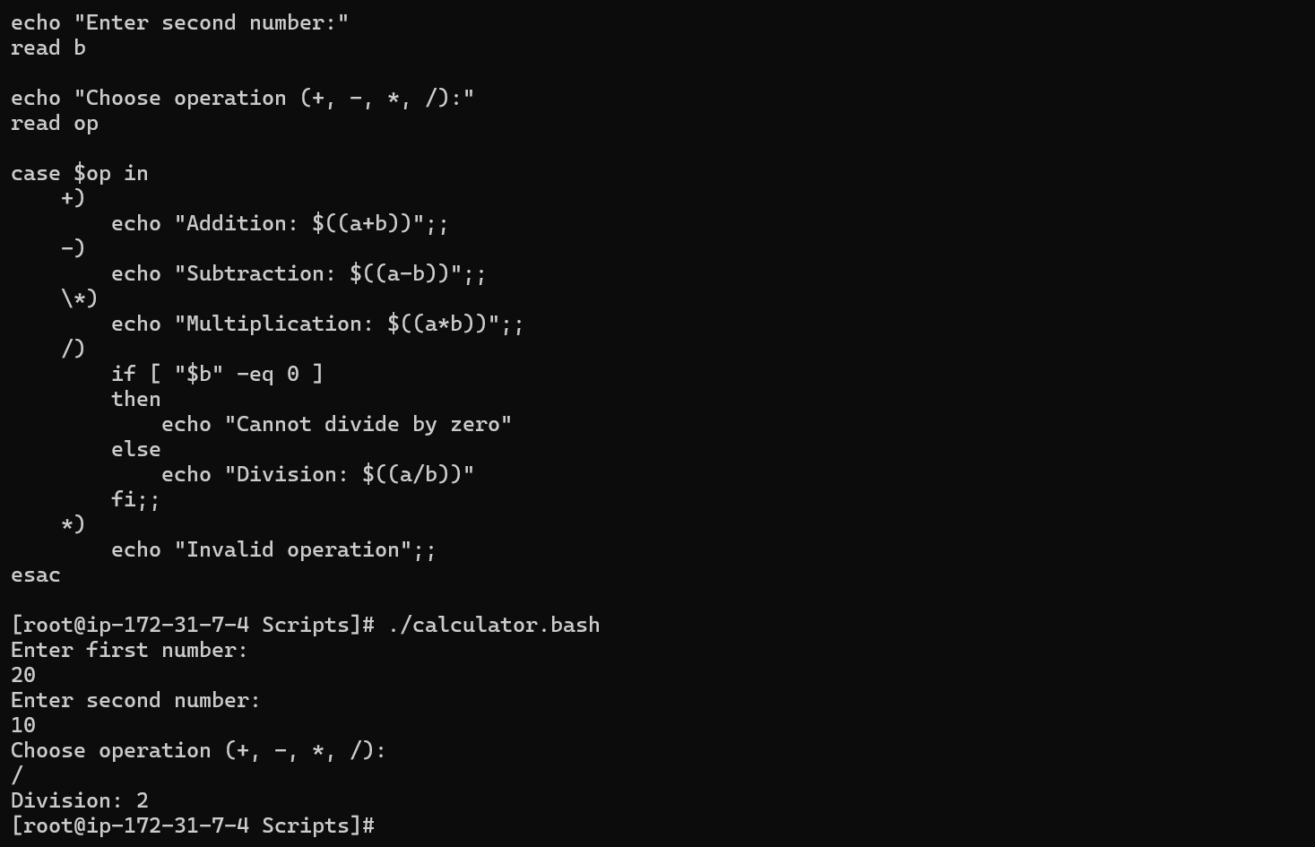
- Create a bash script to check if a directory exists, if not then create a directory.
I already have the directory. I am just using this script to check if the directory is available or not. If not there, it will create a new one.
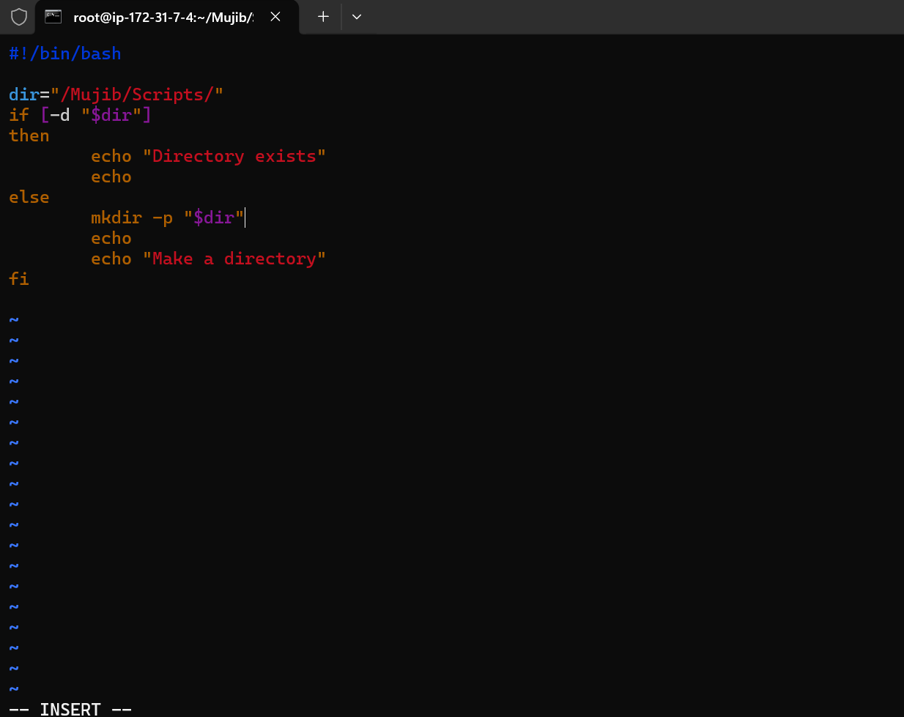
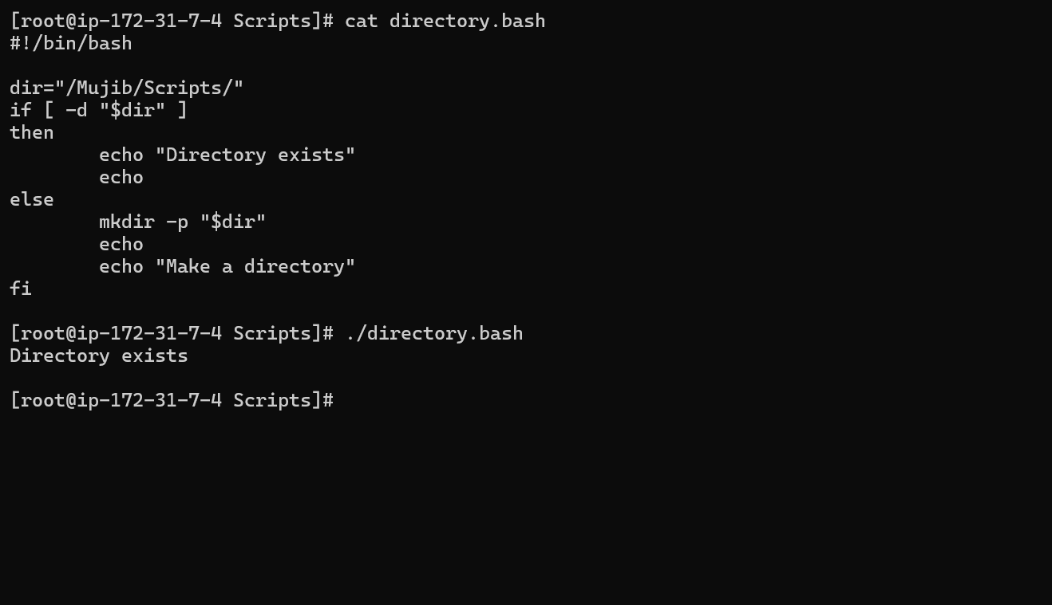
- Create a bash script to delete the last 3 lines of a file.
I used if condition and sed command for deleting the last 3 lines.
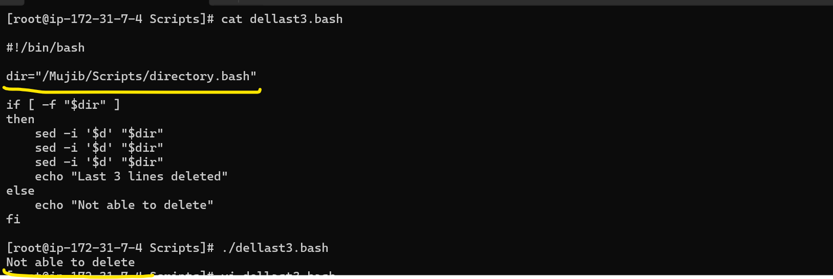
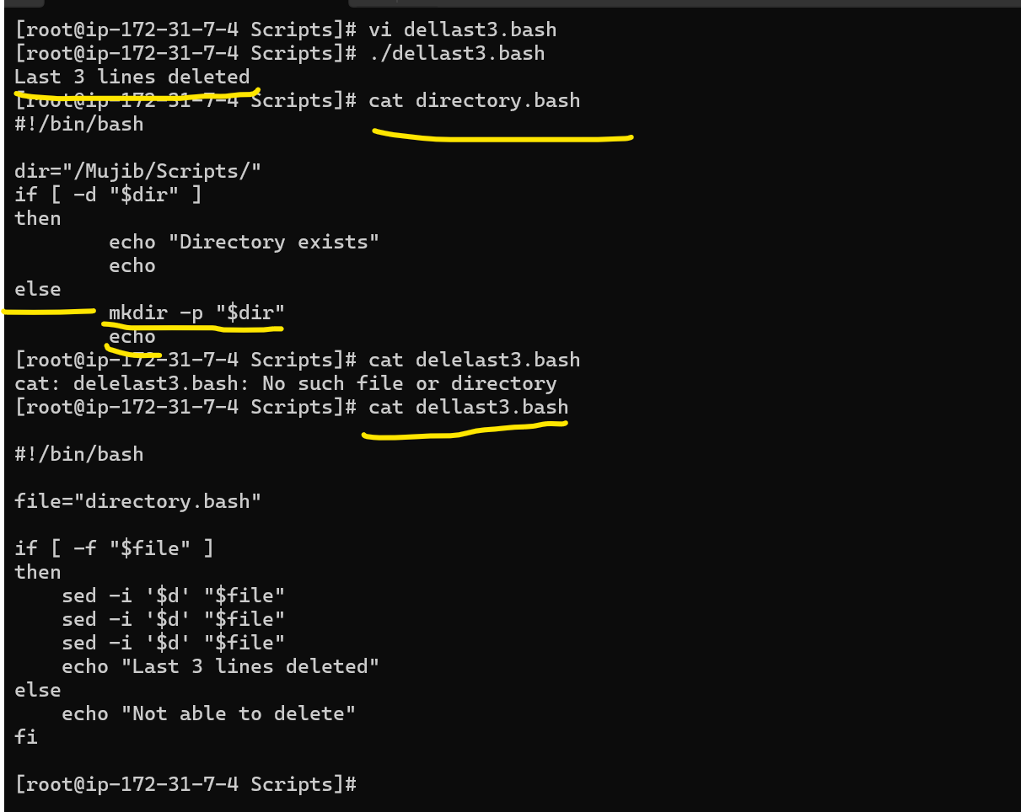
- Bash script to monitor cpu and if it is more than 80% then send email notification.
top Displays system and CPU information.
-b Runs top in batch mode, so it prints output instead of opening an interactive screen.
-n1 Takes one sample and exits.
grep "Cpu(s)" Selects the CPU information line.
awk '{print 100 - $8}' Subtracts the 8th field from 100.
CPU=$(...) Stores the command's result in the CPU variable.
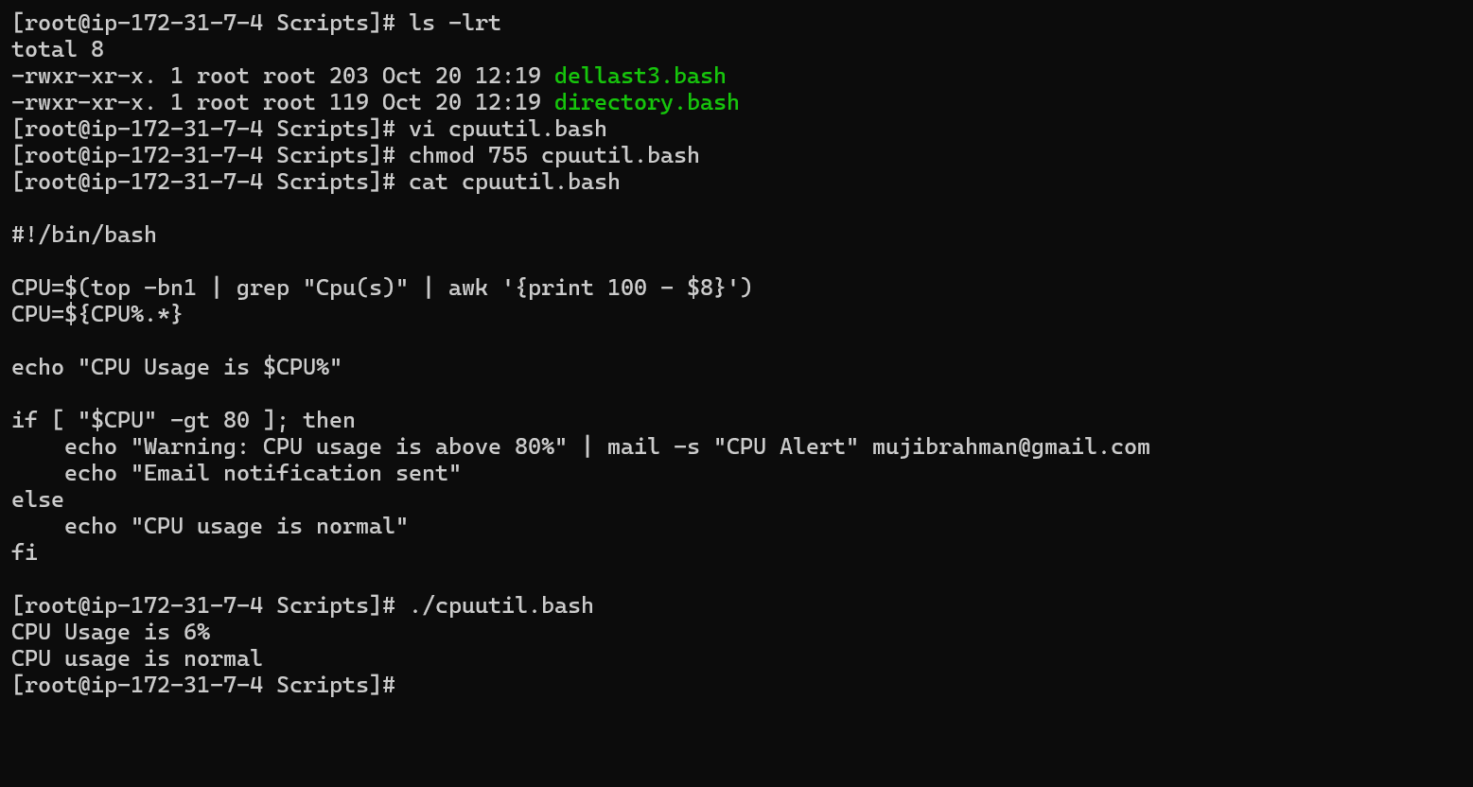
- Bash script to monitor disk space and if it is more than 80% then send email notification.
df / Checks disk space for the filesystem containing /.
awk 'NR==2 {print $5}' Gets the usage percentage from the second output line.
tr -d '%' Removes the % symbol so the result is a number.
-gt 80 Checks whether usage is greater than 80%
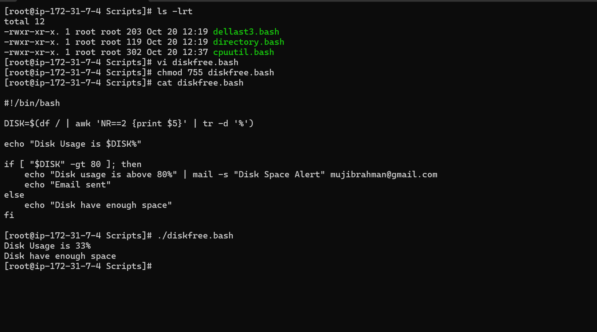
- Bash script to monitor memory and if it is more than 80% then send email notification.
free Displays memory usage.
Awk Calculates memory usage as a percentage.
$3/$2*100 Divides used memory by total memory and multiplies by 100.
-gt 80 Checks whether memory usage is greater than 80%.
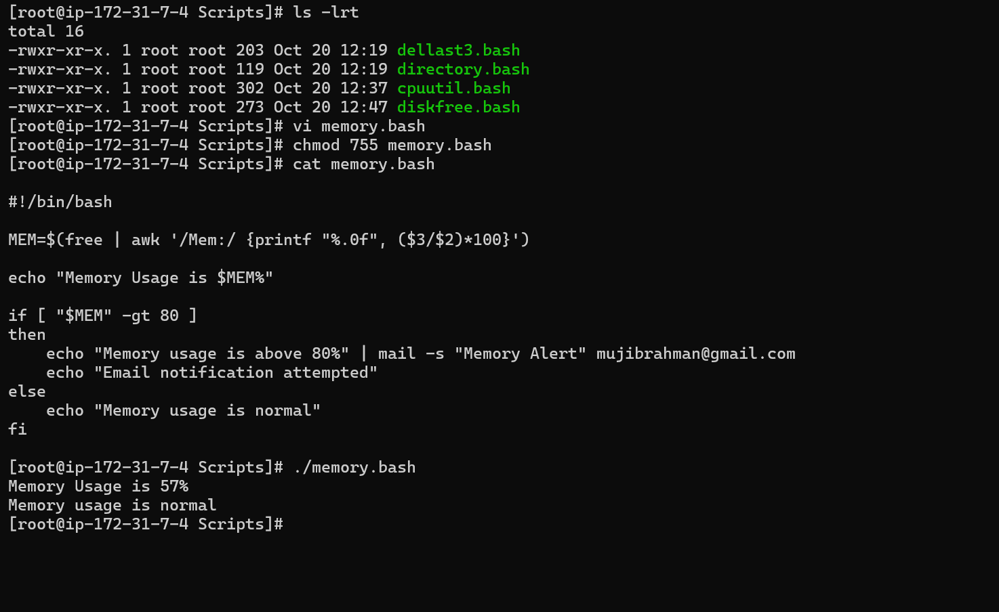
Exercise: Crontab Entries
- April 5th Midnight
0 0 5 4 * /root/cronjob/april5.bash
- 5th of Every November, January, June if it is a Thursday
0 0 5 1,6,11 4 /root/cronjob/thursday.bash
At first, I thought my above answer is correct.
0 0 5 1,6,11 * [ "$(date +\%u)" -eq 4 ] && /root/cronjob/thursday.bash

- At 05 and 27th minutes of 9, 10, 11 hours every day
5,27 9,10,11 * * * /root/cronjob/everydayjob.bash
- 34 minutes of 9th hour on 15th August
34 9 15 8 * /root/cronjob/15august.bash
- Every midnight
0 0 * * * /root/cronjob/everymidnyt.bash
- Every Weekend (Saturday night 11:59 PM)
59 23 * * 6 /root/cronjob/weeklysatjob.bash
- After every reboot
@reboot /root/cronjob/rebootjob.bash

